# **TO ALL STAFF**

The attention of all staff is directed to the information below :-

**Marine Officer**

**Brian Elsegood**

**DOB 15/08/1945**

**2301522**

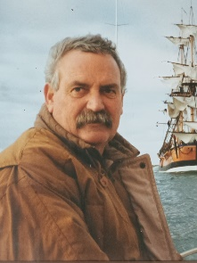

Please be advised of the passing of Retired Marine Officer Brian Elsegood who was laid to rest at a private Family ceremony on the 17th of March 2023.

Brian passed away peacefully while in the Mary Potter Hospice surrounded by family on Saturday the 11th of March 2023.

Brian commenced his SAMFS career on Monday the 12th of January 1976 and retired on Thursday the 1st of July 2004, Brian obtained the Rank of Marine Officer on Friday the 3rd of June 1994.

Brian served SAMFS at Pt Adelaide and Marine Stations.

Brian’s family would like to invite those that would like to attend his memorial which is to be held at the Largs Bay Sailing Club, on Wednesday the 5th of April 2023 at 1400 hours, for some memories and drinks to farewell Brian.

Largs Bay Sailing Club -: 1 The Foreshore Largs Bay 5016 (opposite Everard St, Lady Gowrie Drive)

Yours sincerely,

**Brian Moon  
MFS** **Employee Support Coordinator**

t 08 8204 3650 |  e esc@samfs.sa.gov.au

If you or anyone you know needs assistance, please do not hesitate to reach out to our ESC, EAP Providers MOW (Cognition, Human Psychology, Auspsych, and Converge), or Lifeline

Cognition regularly provides helpful information sheets on a variety of subjects, including relationships, mental health and habits. If you’d like to access these information sheets, please visit the Employee Support section of the Members Only website, or, [click here](https://www.mfs.sa.gov.au/site/members_only/employee_support_program.jsp)